

**Mikell Parsch**

**VP, Global Sales and Chief Development Officer, CTI**

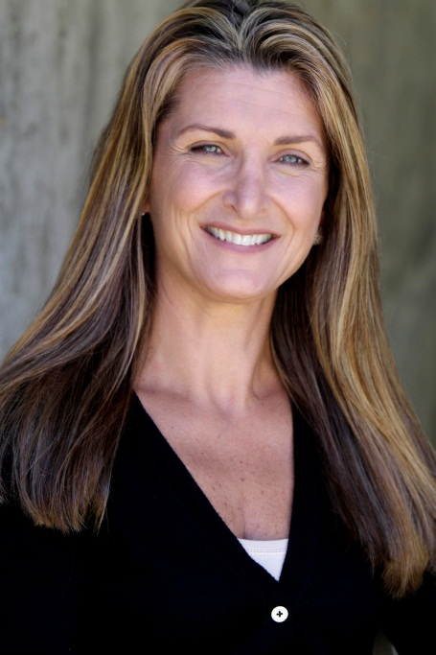

A dynamic, global business leader and sought-after speaker, Parsch has a long, successful track record of growing and transforming companies. Before joining CTI in May 2011, she was the President and COO of Roosevelt Thomas Consulting & Training (RTCT), a diversity management consulting and training organization. Prior to that, she spent 13 years at the Franklin Covey Company, the leading global provider of learning and performance solutions for individuals and organizations, most recently as Executive Vice President and Organizational President. At Franklin, she transformed the Canadian operation into a successful model for International, took responsibility for the International Sales and Operations and focused on development of markets in Latin America and Europe.

Parsch was featured in *Global Explorers*, *The Next Generation of Leaders*, which recognized her entrepreneurial spirit and successful global achievements. Originally from Toronto, she received a degree in Business Management at Sheridan College and a Bachelor Degree in Sociology at the University of Western Ontario. An entrepreneur at heart, she owned and operated her own successful general contractor and maintenance firm. She also served as an independent business consultant and executive coach. Parsch is known for helping her colleagues discover capabilities beyond their imagination and her open, collaborative management style.